**User Guide**

**SBR**



USER GUIDE - SBR

*Modern Statistics Platform*

**Revision History**

|  |  |  |  |
| --- | --- | --- | --- |
| Name | Date | Reasons of Changes | Version |
| iTM | 08th October 2023 | The first draft of SBR MauStats. | V1 |
| iTM | 17th June 2024 | The second draft of SBR MauStats. | V2 |

**Table of Contents**

1.0 INTRODUCTION 4

2.0 SBR 5

2.1 ENTERPRISE GROUP 6

2.1.1 EXPORT 6

2.1.2 IMPORT 8

2.1.3 ADD 9

2.2 ENTERPRISE 10

2.2.1 IMPORT 14

2.2.2 ADD 16

2.2.3 FILTER 17

2.3 ESTABLISHMENT 19

2.3.1 IMPORT 23

2.3.2 ADD 24

2.3.3 FILTER 25

2.4 SNAPSHOT 27

2.4.1 ADD 27

2.5 COMMON FRAME 29

2.5.1 ADD 29

2.6 SURVEY FRAME 32

2.6.1 ADD 32

2.7 SUPPLEMENTARY FRAME 35

2.7.1 ADD 35

# 1.0 INTRODUCTION

The Modern Statistics (MauStats) Platform is developed as a web-based platform with a central database to ensure consistency, security and accessibility. The platform is used to help to automate and integrate data lifecycle from acquisition to dissemination using Generic Statistical Business Process Model (GSBPM) framework. The platform complies to manage data requirements for Census, SEE, and SBR processed data in this phase. It is also feasible for data integration based on SM requirements. This web-based platform consists of the two applications – User Interface and Data Management System (DMS).

In this user guide, we will be learning on how to use the SBR module of the DMS application.

# 2.0 SBR

The SBR module comprises seven submodules which allows management and administration of enterprise, establishment, snapshot and frames. Below are the sub-modules of the SBR elements–

* Enterprise Group
* Enterprise
* Establishment
* Snapshot
* Common Frame
* Survey Frame
* Supplementary Frame

Let us learn how to use these sub-modules in detail.

## ENTERPRISE GROUP

This submodule allows the authorized users to create and manage the enterprise groups master list.

**Step 1:** Click on the **Enterprise Group** option available under SBR to access this sub-module. You have the options to add, import and export, edit, delete and enable/disable the elements (see below figure).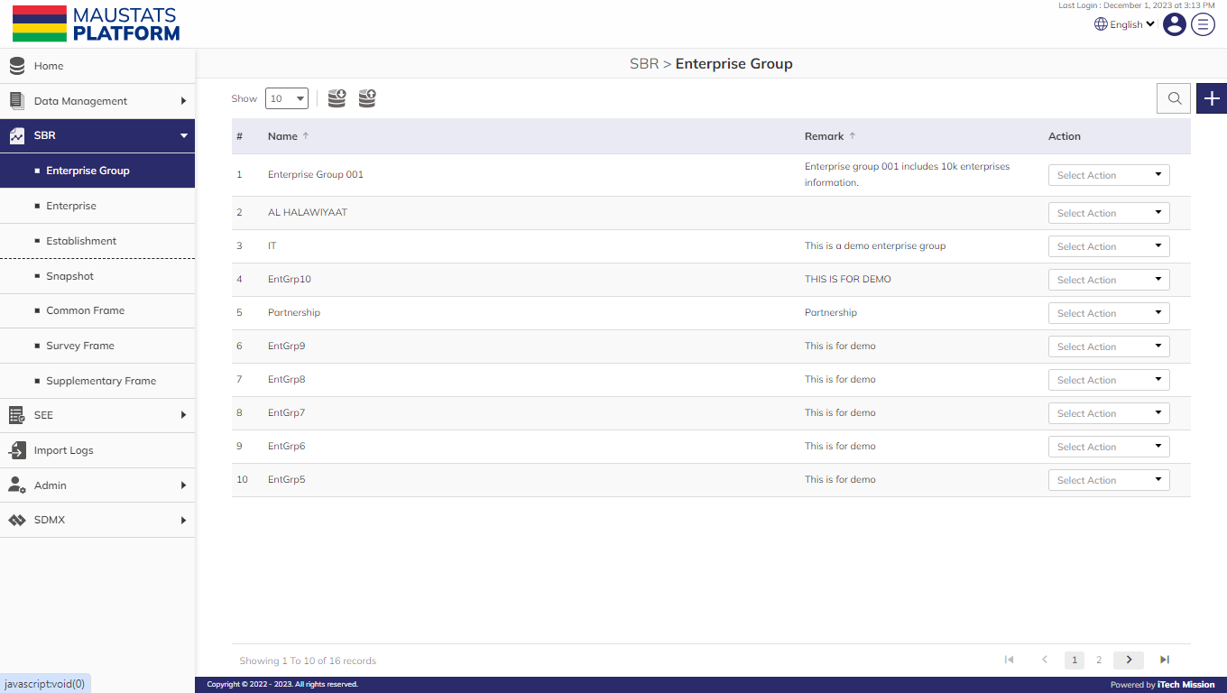

### 2.1.1 EXPORT

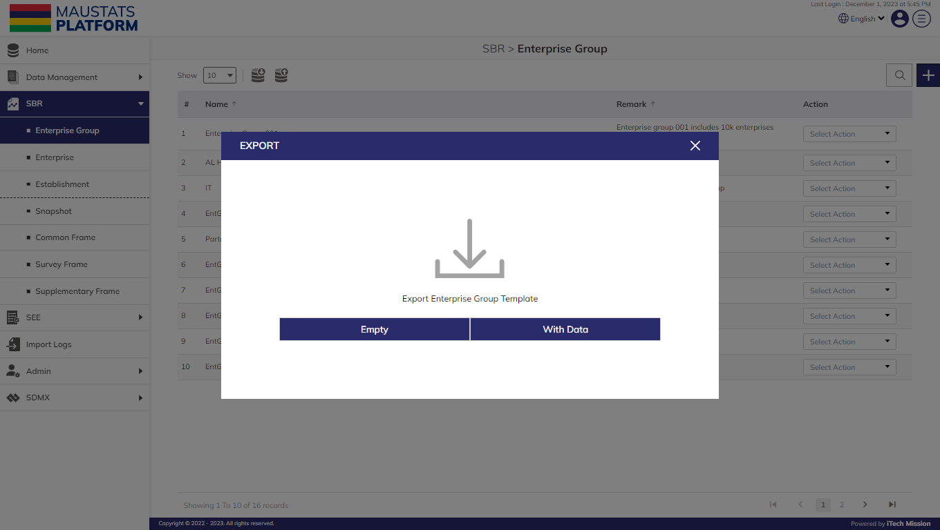**Step 2:** Click on the **Export** button to download the empty enterprise group template and the enterprise group master list available in the database (see below figure).

You can use this option to create an enterprise group template structure. Below is the structure that you will find in the enterprise group template.

|  |  |
| --- | --- |
| **Name** | The name of the enterprise group. |
| **Remark** | The remarks to associate with the enterprise group. |

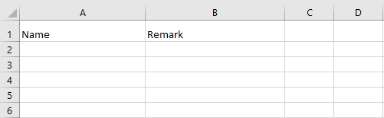**Step 3:** Click on the **Empty** option to download an empty enterprise group template. The enterprise group list is imported and exported in the CSV (Comma Separated Value) file format.

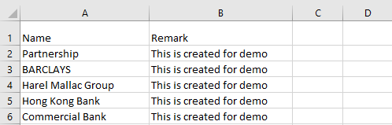**Step 4:** Click on the **With Data** option to download the enterprise group master list.

### 2.1.2 IMPORT

**Step 5:** Click on the **Import** button to browse the file and upload the enterprise group master list into the database.

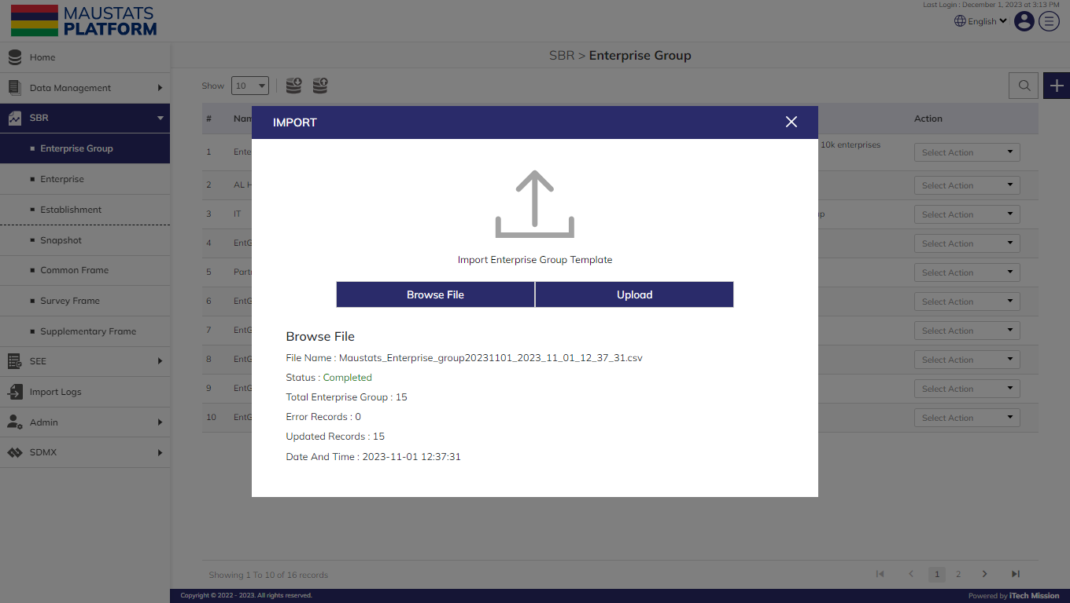To upload the enterprise group into the database, first enter the enterprise group structure in the template as explained above and then click on the Browse File button to select the template. Now, click on the Upload button to start the import process (see below figure).

During the import process, the records which contain blank entries, entries with special characters and duplicate entries are not imported in the database. A Last Upload summary will appear after the import process which provides the count of successfully imported records out of the total records. An error log will be generated to report on unsuccessful imported records which you can access from the Log module.

### 2.1.3 ADD

**Step 6:** Click on the Plus button available to the right side of the page to add a new enterprise group (see figure below). Enter the following details to add a new element.

* Enter **Name**
* 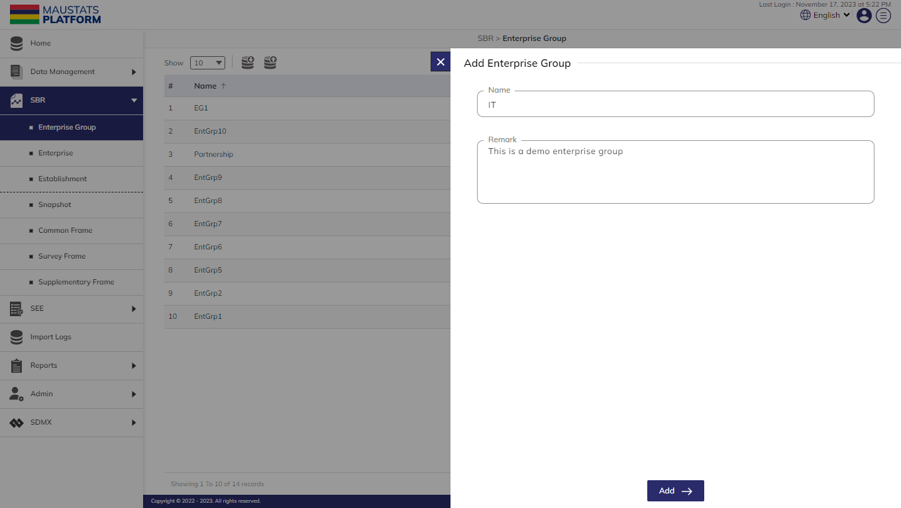Enter **Remark**

Blue color details are mandatory to be entered.Click on the **Add** button to save and confirm. You can now view the new enterprise group added in the list.

**Step 7:** Click to select **Edit** option available in the action dropdown to edit the details of the selected element. Edit the required detail and click on the update button to save and confirm.

**Step 8:** Click to select the Delete option available in the action dropdown to delete the selected element. A confirmation popup will appear, click yes to confirm deletion of selected elements.

**Step 9:** Click to select **Enable/Disable** option available in the action dropdown to show or hide the specific element. The hidden element will not be shown throughout the application.

## ENTERPRISE

This submodule allows the authorized users to create and manage the enterprise master list.

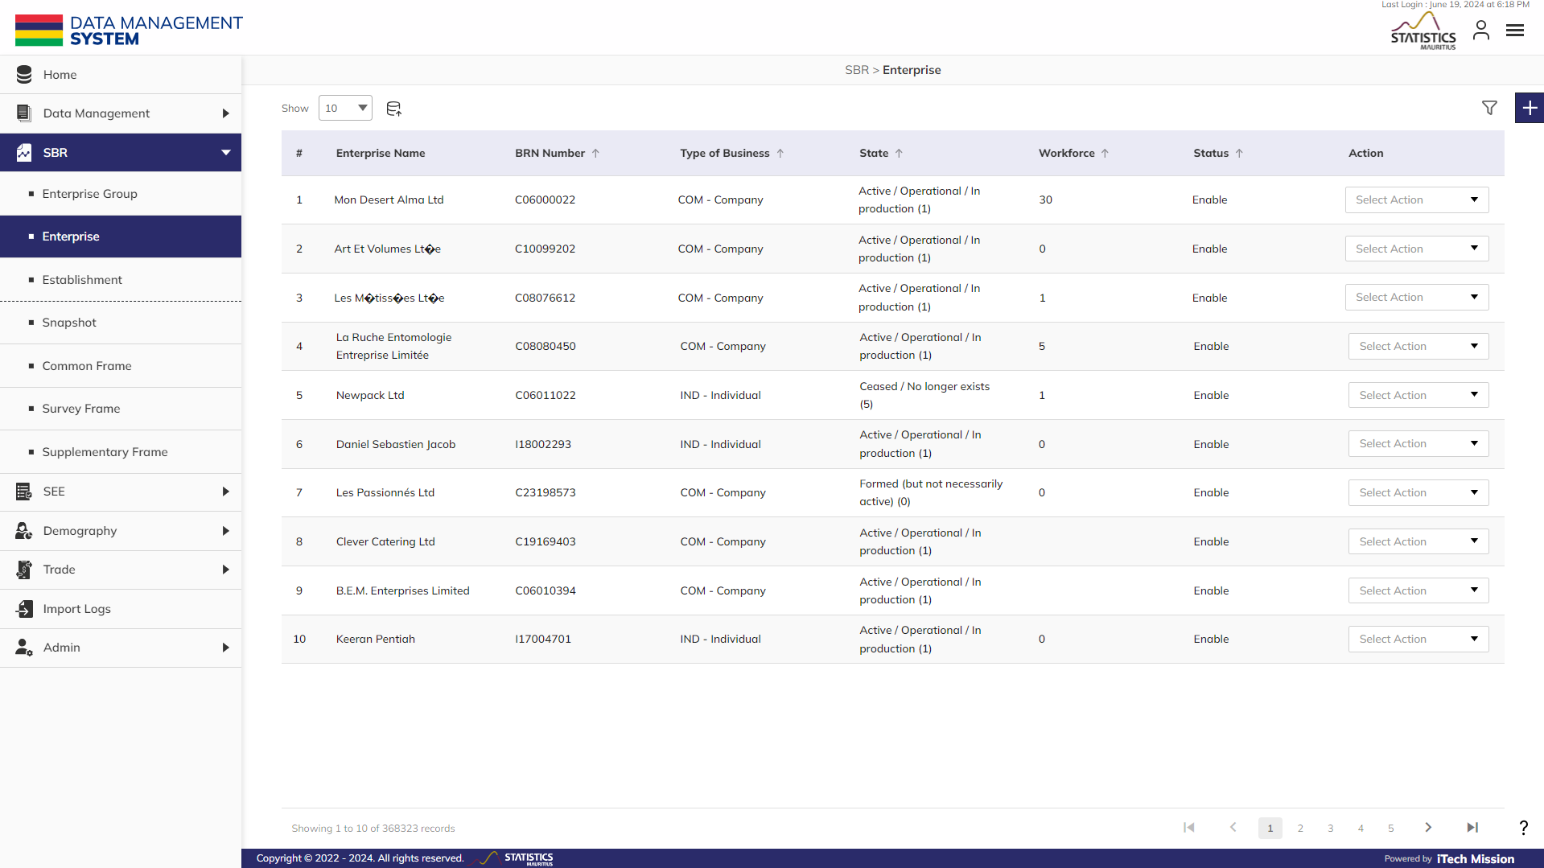**Step 1:** Click on the **Enterprise** option available under SBR to access this sub-module. You have the options to add, import and export, edit, delete, enable/disable and filter the elements (see below figure).

You can use this option to create an enterprise template structure. Below are the fields of the enterprise along with their respective data types and import rules.

|  |  |  |  |
| --- | --- | --- | --- |
| **Field** | **Type** | **Length or Choice Type** | **Mandatory** |
| Id | Number | Auto generated |  |
| Name | Text |  | Yes |
| Source of name | Text |  | No |
| Previous name | Text |  | No |
| Trading name | Text |  | No |
| Type of business | List | Single Choice | Yes |
| State | List | Single Choice | Yes |
| Enterprise group | List | Single Choice | No |
| Main activity | List | Single Choice | Yes |
| Main activity description | Text |  | No |
| Secondary activities | List | MultiChoice | No |
| Ancillary activities | List | MultiChoice | No |
| Companies division trade code | Numeric | 6 | No |
| Activities matching trade code | Numeric |  | No |
| Institutional sector | List | Single Choice | Yes |
| Export oriented | Checkbox | Boolean (Yes or No as value while importing) | No |
| Information source | List | Single choice | No |
| Type of company | List | Single Choice | No |
| Global business category | List | Single Choice | No |
| Ministry division | List | Single Choice | No |
| Type of ownership | List | Single Choice | No |
| % Mauritian ownership | Numeric | Limit up to 3 characters | No |
| % Foreign ownership | Numeric | Limit up to 3 characters | No |
| Title | Text |  | No |
| First name | Text |  | No |
| Last name | Text |  | No |
| Id number | Number |  | No |
| Passport number | Alphanumeric |  | No |
| Business registration number | Alphanumeric | Limit up to 9 characters | Yes |
| Previous BRN | Alphanumeric | Limit up to 9 characters | No |
| Tax account number | Numeric | Limit up to 8 characters | No |
| Vat account number | Text |  | No |
| Social security number | Text |  | No |
| Created | Date |  | No |
| Closed | Date |  | No |
| Restored | Date |  | No |
| Started operating | Date |  | No |
| Ceased operating | Date |  | No |
| Changed name | Date |  | No |
| Address | Text |  | Yes |
| MVCA | List | Single Choice | Yes |
| Optional locality - select for automatic derivation of MVCA |  | Single Choice | No |
| Optional street name - select for automatic derivation of MVCA |  | Single Choice | No |
| Title or designation | Text |  | No |
| Contact person | Text |  | No |
| Position | Text |  | No |
| Telephone 1 | Number | (Code +230) 8 Characters | No |
| Telephone 2 | Number | (Code +230) 8 Characters | No |
| Fax | Number | Limit up to 20 characters | No |
| Email | Text |  | No |
| Address 1 | Text |  | No |
| Address 2 | Text |  | No |
| Address 3 | Text |  | No |
| Address 4 | Text |  | No |
| Address 5 | Text |  | No |
| Title or designation | Text |  | No |
| Contact person | Text |  | No |
| Position | Text |  | No |
| Telephone 1 | Number | (Code +230) 8 Characters | No |
| Telephone 2 | Number | (Code +230) 8 Characters | No |
| Fax | Number | Limit up to 20 characters | No |
| Email | Text |  | No |
| Address 1 | Text |  | No |
| Address 2 | Text |  | No |
| Address 3 | Text |  | No |
| Address 4 | Text |  | No |
| Address 5 | Text |  | No |
| Turnover | Number | Limit up to 11 characters | No |
| Male employment | Number | Limit up to 9 characters | No |
| Female employment | Number | Limit up to 9 characters | No |
| Workforce | Number | Limit up to 9 characters | No |
| Workforce source | List | Single Choice | No |
| Foreign male employment | Number | Limit up to 9 characters | No |
| Foreign female employment | Number | Limit up to 9 characters | No |
| Foreign workforce | Number | Limit up to 9 characters | No |
| Acreage under cultivation | Number | Limit up to 9 characters | No |
| Forbidden Deletion? | Checkbox |  | No |
| Remarks | Text area |  | No |

### 2.2.1 IMPORT

Data of enterprises and establishments is received from external sources. In order to seamlessly integrate this data into the MauStats platform, a mapping file is created to transform the externally received data into a compatible format. Below is the list of external sources from where we receive the enterprise and establishment data.

**NOTE:**

When an enterprise is added or imported, by default the platform creates an establishment with same BRN number and unique Establishment ID.

|  |  |  |
| --- | --- | --- |
| **Source** | **Import Type** | **Data** |
| CBRD | Add | New Enterprise |
| CBRD | Update | Name of enterprises |
| CBRD | Update | Defunct enterprises |
| CBRD | Update | Restored enterprises |
| MRA | Update | VAT Returns |
| CISD | Update | Employment and earnings |
| SEE | Update | Survey |

**Step 2:** Click on the **Import** button to browse the file and upload the enterprise master list into the database.

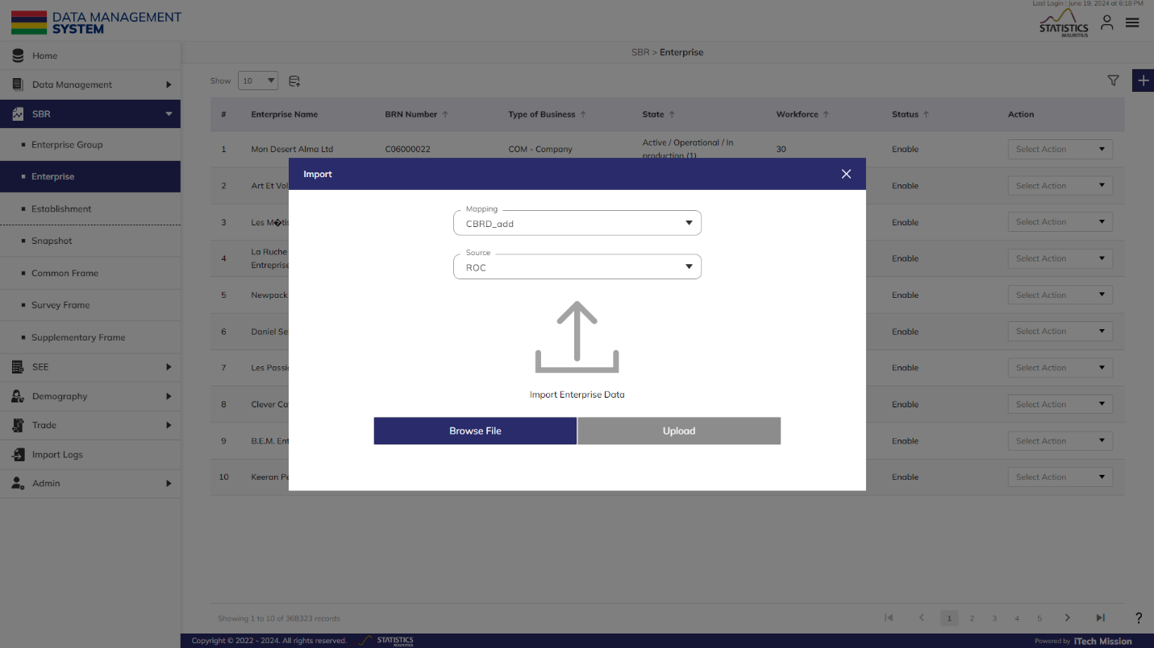To upload the enterprise master list into the database, select mapping file, source and then click on the Browse File button to select the enterprise data file to be imported. Now, click on the Upload button to start the import process (see below figure).

During the import process, the records which contain blank entries, entries with special characters and duplicate entries are not imported in the database. A Last Upload summary will appear after the import process which provides the count of successfully imported records out of the total records. An error log will be generated to report on unsuccessful imported records which you can access from the Import **Logs** module.

### 2.2.2 ADD

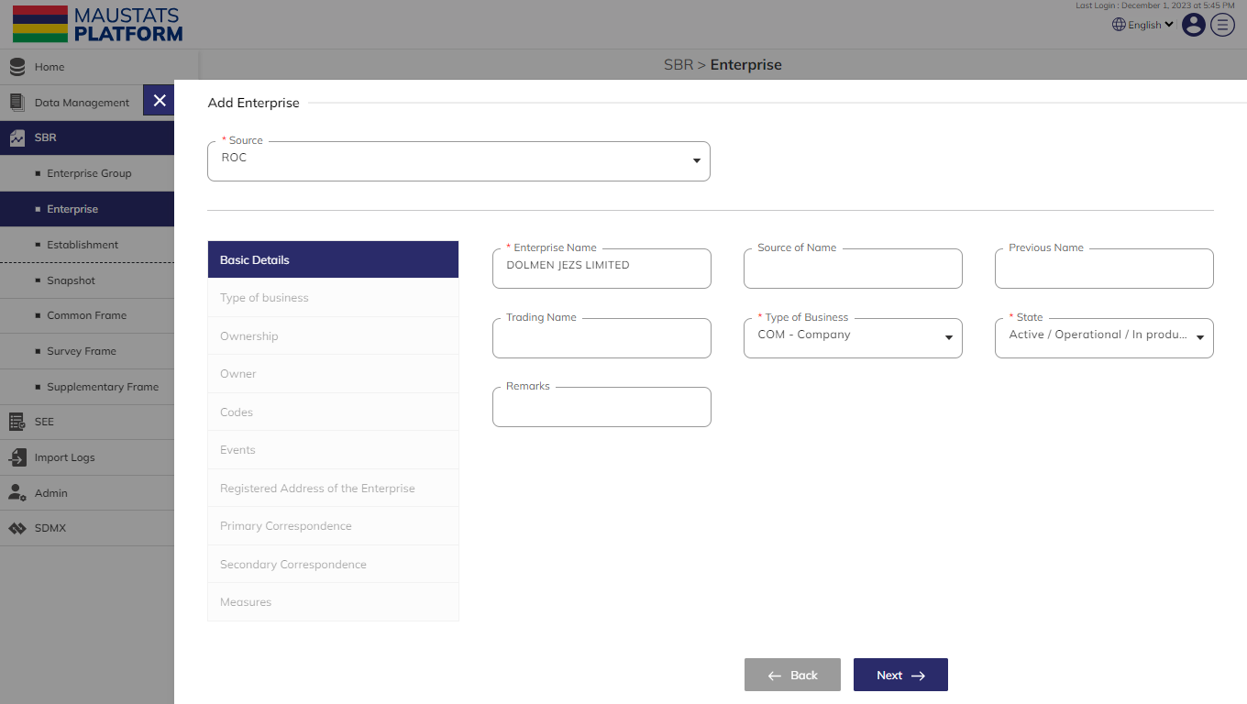**Step 3:** Click on the Plus button available to the right side of the page to add a new enterprise (see figure below).

The Add Enterprise form is divided into sections namely – Basic Details, Type of business, Ownership, Owner, Codes, Events, Registered Address of the Enterprise, Primary Correspondence, Secondary Correspondence and Measures. All the mandatory fields should have relevant data for the Next button to get enabled. Navigate from one section to another using the Nextand **Previous** button available in each section.

Click on the **Submit** button available in the last section of the Add Enterprise form to save and confirm. You can now view the new enterprise added in the list.

**Step 4:** Click to select **Edit** option available in the action dropdown to edit the details of the selected element. Edit the required detail and click on the update button to save and confirm.

**NOTE:**

You can edit the source of a record manually, message regarding precedence will appear. Click on **Ok** to confirm and source name will be changed. This feature is not available while importing.

**Step 5:** Click to select the **Delete** option available in the action dropdown to delete the selected element. A confirmation popup will appear, click yes to confirm deletion of selected elements.

**Step 6:** Click to select **Enable/Disable** option available in the action dropdown to show or hide the specific element. The hidden element will not be shown throughout the application.

### 2.2.3 FILTER

**Step 7:** Click on the **Filter** button available to the right side of the page to filter the enterprise list based on the specified criteria.

Suppose you want to filter the enterprise where the “workforce” is “greater than” <10>.

The above statement comprises of -

1. “workforce “as **Column**
2. “Greater than (>)” as **Operator**
3. <10> as **Value**

Click on the **Add** button to confirm saving the filter. You can apply multiple criteria by adding multiple filters one by one following a similar approach to add each one separately. You can also add multiple filters at once by clicking on the **Plus** button available in the first filter row (see below figure).

**NOTE:**

To apply and operations on multiple filters, you will have to add them individually. However, if you wish to apply more than one filter using the OR operation, add all those filters simultaneously.

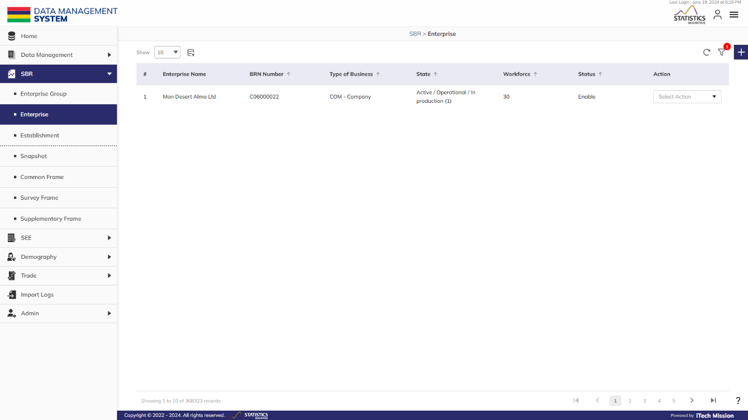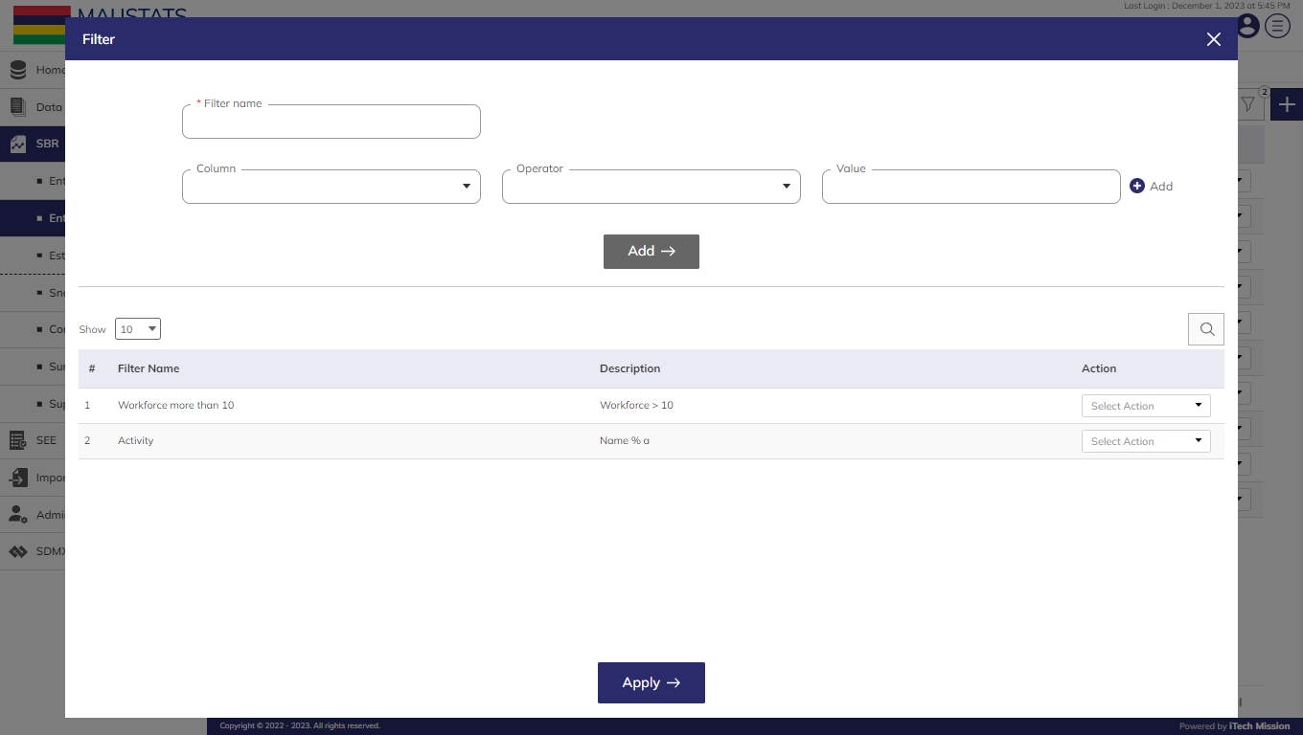Click on the **Apply** button to filter the enterprise list based on saved filters (see below figure).

## ESTABLISHMENT

This submodule allows the authorized users to create and manage the establishment master list.

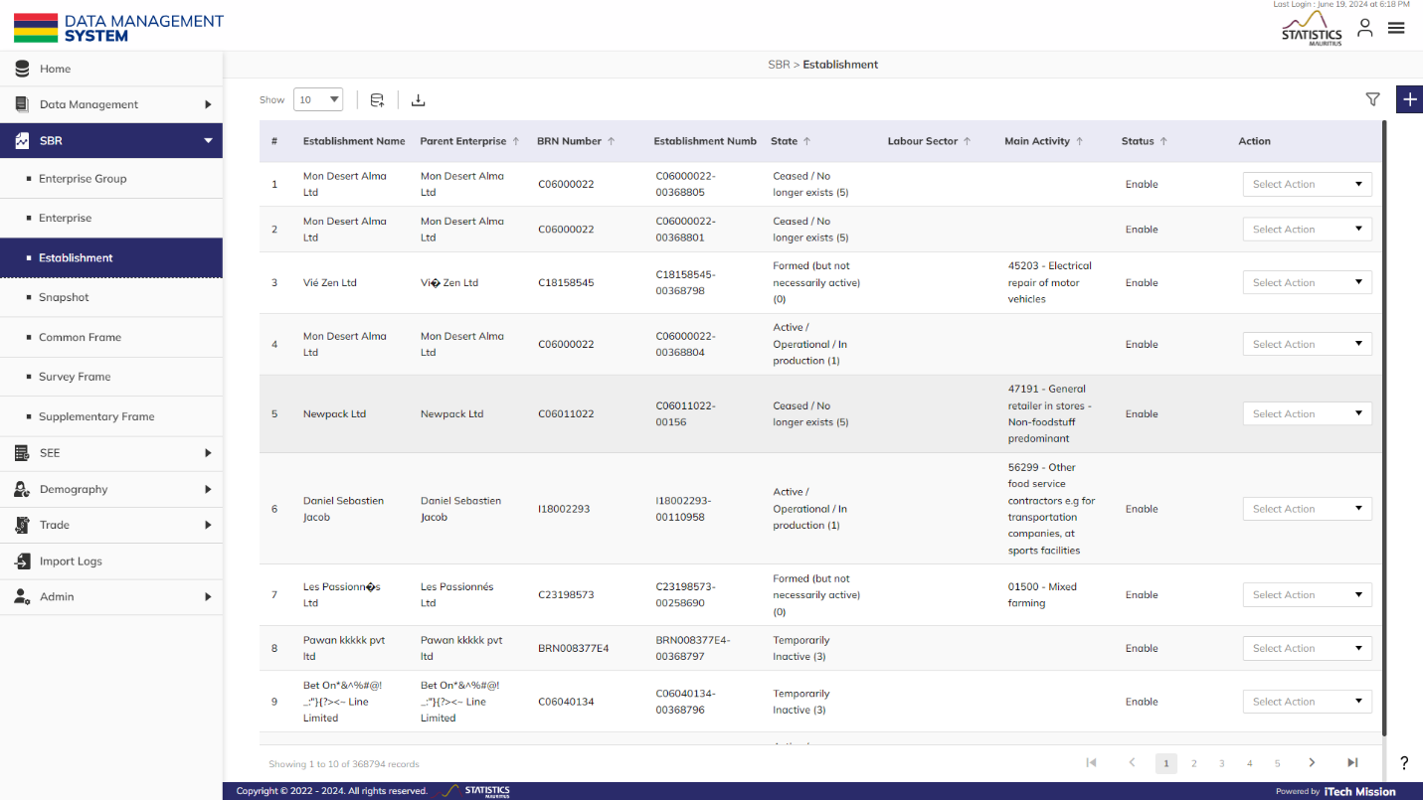**Step 1:** Click on the **Establishment** option available under SBR to access this sub-module. You have the options to add, import and export, edit, delete, enable/disable and filter the elements (see below figure).

You can use this option to create an establishment template structure. Below are the fields of the establishment along with their respective data types and import rules.

|  |  |  |  |
| --- | --- | --- | --- |
| **Field** | **Type** | **Rules** | **Mandatory** |
| Establishment Id | Number | Auto generated |  |
| Enterprise Name | Text | Auto filled | Yes |
| Source of name | Text | Auto filled | No |
| Previous name | Text | Auto filled | No |
| Trading name | Text | Auto filled | No |
| Type of business | List | Auto filled | Yes |
| State | List | Auto filled | Yes |
| Enterprise group | List | Single Choice | No |
| Main activity | List | Single Choice | Yes |
| Main activity description | Text |  | No |
| Secondary activities | List | MultiChoice | No |
| Ancillary activities | List | MultiChoice | No |
| Companies division trade code | Numeric | 6 | No |
| Activities matching trade code | Numeric |  | No |
| Institutional sector | List | Single Choice | Yes |
| Export oriented | Checkbox | Boolean | No |
| Information source | List | Single choice | No |
| Type of company | List | Single Choice | No |
| Global business category | List | Single Choice | No |
| Ministry division | List | Single Choice | No |
| Type of ownership | List | Single Choice | No |
| % Mauritian ownership | Numeric | Limit up to 3 characters | No |
| % Foreign ownership | Numeric | Limit up to 3 characters | No |
| Title | Text |  | No |
| First name | Text |  | No |
| Last name | Text |  | No |
| Id number | Number |  | No |
| Passport number | Alphanumeric |  | No |
| Business registration number | Alphanumeric | Limit up to 9 characters | Yes |
| Previous BRN | Alphanumeric | Limit up to 9 characters | No |
| Tax account number | Numeric | Limit up to 8 characters | No |
| Vat account number | Text |  | No |
| Social security number | Text |  | No |
| Created | Date |  | No |
| Closed | Date |  | No |
| Restored | Date |  | No |
| Started operating | Date |  | No |
| Ceased operating | Date |  | No |
| Changed name | Date |  | No |
| Address | Text |  | Yes |
| MVCA | List | Single Choice | Yes |
| Optional locality - select for automatic derivation of MVCA |  | Single Choice | No |
| Optional street name - select for automatic derivation of MVCA |  | Single Choice | No |
| Title or designation | Text |  | No |
| Contact person | Text |  | No |
| Position | Text |  | No |
| Telephone 1 | Number | (Code +230) 8 Characters | No |
| Telephone 2 | Number | (Code +230) 8 Characters | No |
| Fax | Number | Limit up to 20 characters | No |
| Email | Text |  | No |
| Address 1 | Text |  | No |
| Address 2 | Text |  | No |
| Address 3 | Text |  | No |
| Address 4 | Text |  | No |
| Address 5 | Text |  | No |
| Title or designation | Text |  | No |
| Contact person | Text |  | No |
| Position | Text |  | No |
| Telephone 1 | Number | (Code +230) 8 Characters | No |
| Telephone 2 | Number | (Code +230) 8 Characters | No |
| Fax | Number | Limit up to 20 characters | No |
| Email | Text |  | No |
| Address 1 | Text |  | No |
| Address 2 | Text |  | No |
| Address 3 | Text |  | No |
| Address 4 | Text |  | No |
| Address 5 | Text |  | No |
| Turnover | Number | Limit up to 11 characters | No |
| Male employment | Number | Limit up to 9 characters | No |
| Female employment | Number | Limit up to 9 characters | No |
| Workforce | Number | Limit up to 9 characters | No |
| Workforce source | List | Single Choice | No |
| Foreign male employment | Number | Limit up to 9 characters | No |
| Foreign female employment | Number | Limit up to 9 characters | No |
| Foreign workforce | Number | Limit up to 9 characters | No |
| Acreage under cultivation | Number | Limit up to 9 characters | No |
| Forbidden Deletion? | Checkbox |  | No |
| Remarks | Text area |  | No |

### 2.3.1 IMPORT

**Step 2:** Click on the **Import** button to browse the file and upload the establishment master list into the database.

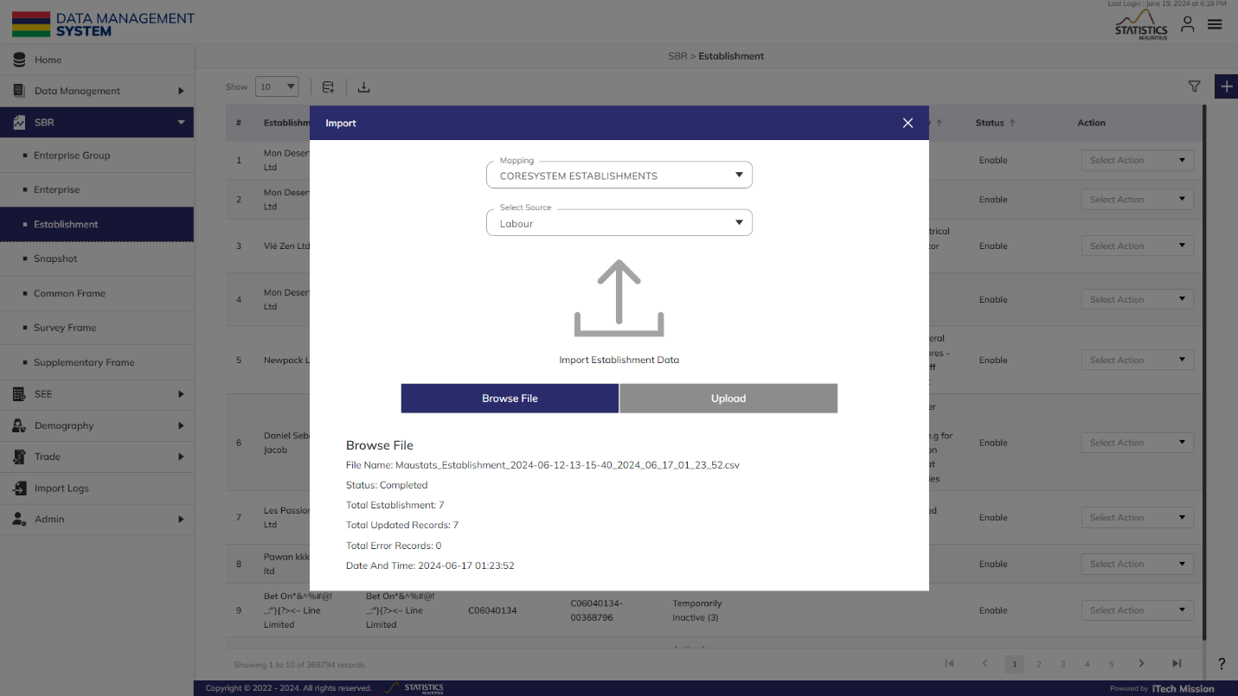To upload the establishment master list into the database, select mapping file, source and then click on the Browse File button to select the enterprise data file to be imported. Now, click on the Upload button to start the import process (see below figure).

During the import process, the records which contains blank entries, entries with special characters and duplicate entries are not imported in the database. A Last Upload summary will appear after the import process which provides the count of successfully imported records out of the total records. An error log will be generated to report on unsuccessful imported records which you can access from **Import Logs** module.

### 2.3.2 ADD

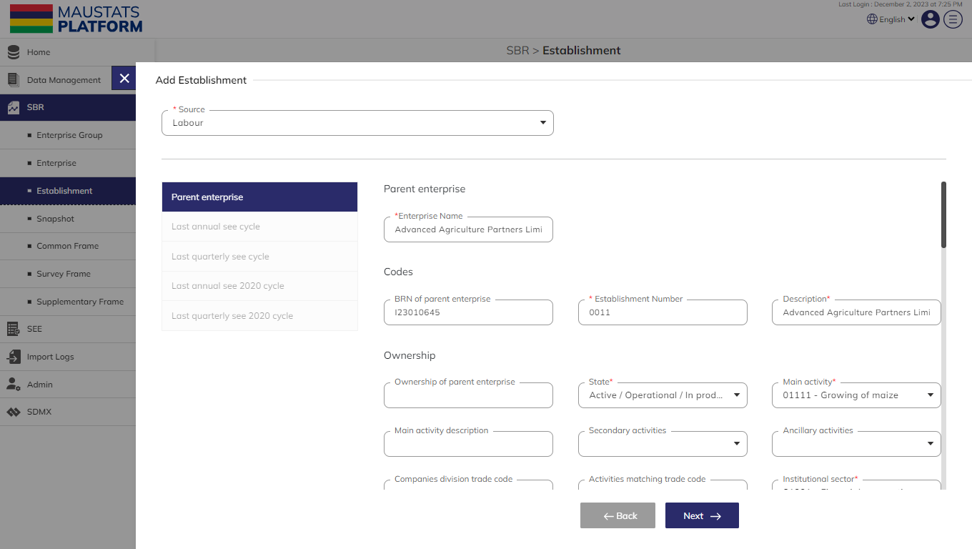**Step 3:** Click on the Plus button available to the right side of the page to add a new enterprise (see figure below).

The Add Establishment form is divided into sections namely – Parent Enterprise, Last See Cycle, Last Quarterly Cycle and Last Annual Cycle. All the mandatory fields should have relevant data for the **Next** button to get enabled. Navigate from one section to another using the **Next** and **Previous** button available in each section.

Click on the **Submit** button available in the last section of the Add Establishment form to save and confirm. You can now view the new establishment added in the list.

**Step 4:** Click to select **Edit** option available in the action dropdown to edit the details of the selected element. Edit the required detail and click on the **update** button to save and confirm.

**Step 5:** Click to select the **Delete** option available in the action dropdown to delete the selected element. A confirmation popup will appear, click yes to confirm deletion of selected elements.

**Step 6:** Click to select **Enable/Disable** option available in the action dropdown to show or hide the specific element. The hidden element will not be shown throughout the application.

### 2.3.3 FILTER

**Step 7:** Click on the **Filter** button available to the right side of the page to filter the establishment list based on the specified criteria.

Suppose you want to filter the establishment where the “workforce” is “greater than” <10>.

The above statement comprises of -

1. “workforce “as **Column**
2. “Greater than (>)” as **Operator**
3. <10> as **Value**

Click on the **Add** to confirm saving the filter. You can apply multiple criteria by adding multiple filters one by one following a similar approach to add each one separately. You can also add multiple filters at once by clicking on the **Plus** button available in the first filter row (see below figure).

**NOTE:**

If any data file with similar structure already ingested, you have the option to copy its settings in the current file. To proceed with this, refer to step 4; otherwise, you can skip this step if you are importing a new data file.

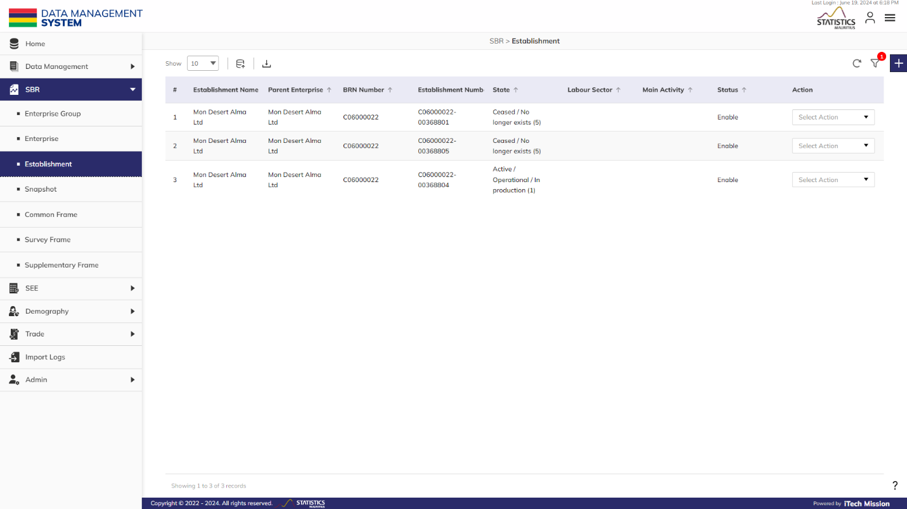Click on the **Apply** button to filter the establishment list based on saved filters (see below -figure).

## SNAPSHOT

This submodule allows the authorized users to create and manage snapshots.

**Step 1:** Click on the **Snapshot** option available under SBR to access this sub-module. You have the options to add and delete the elements (see below figure).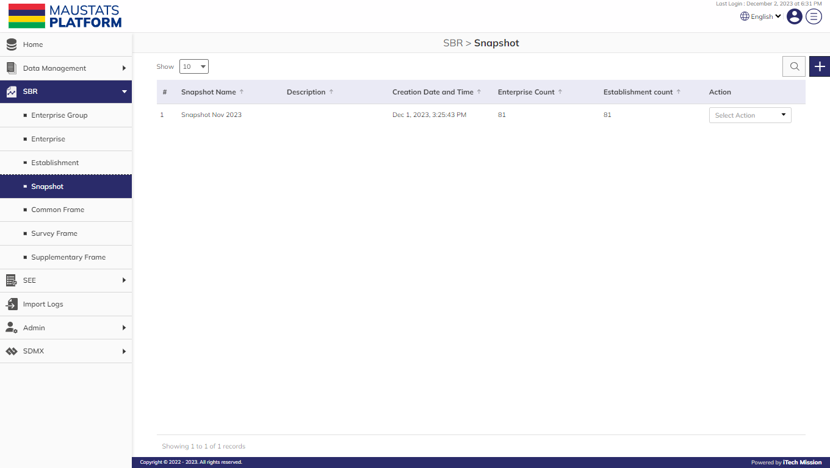

### 2.4.1 ADD

**Step 2:** Click on the Plus button available to the right side of the page to add a new snapshot (see figure below). Enter the following details to add a new element.

* Enter **Snapshot** **Name**
* Enter **Snapshot Description**

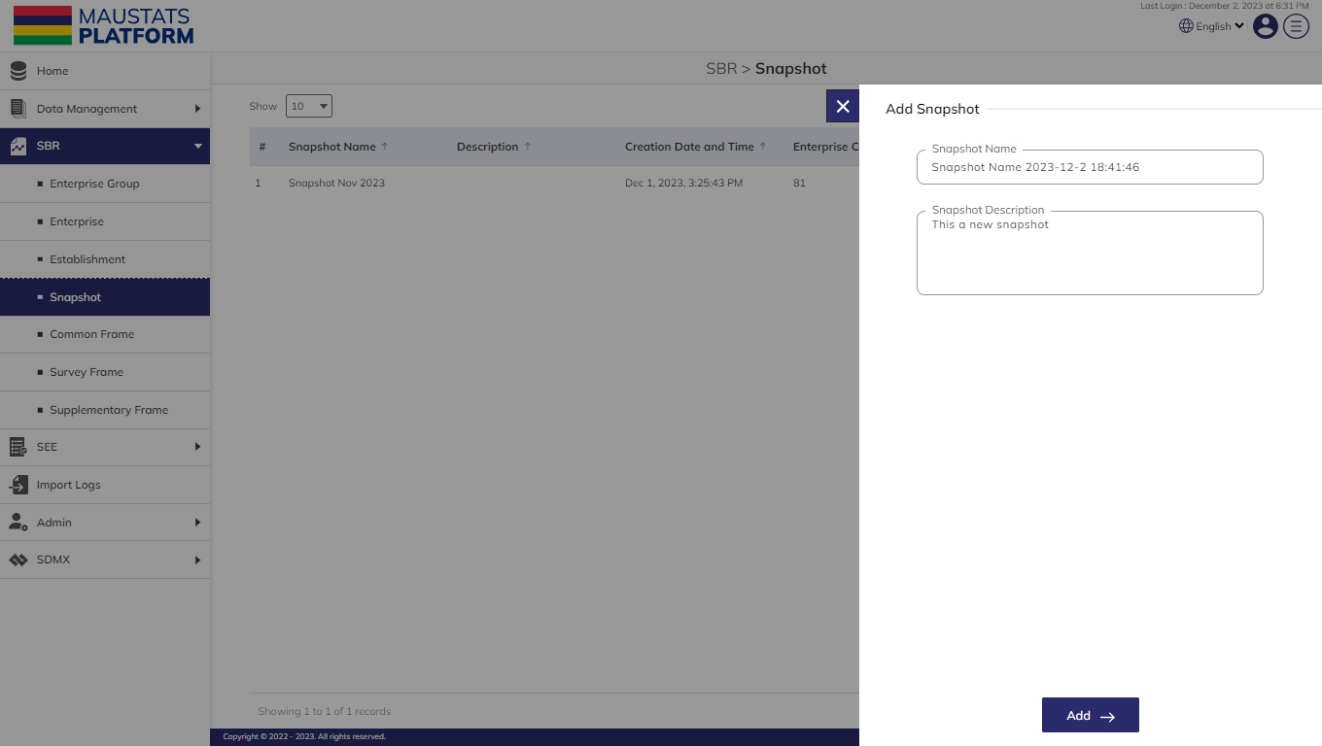**Step 3:** Click on the **Add** button to save and confirm. You can now view the new snapshot added in the list.

**Step 4:** Click to select **View** **Enterprise** option available in the action dropdown to view the list of the enterprise available in the snapshot.

**Step 5:** Click to select **View** **Establishment** option available in the action dropdown to view the list of the establishments available in the snapshot.

**Step 6:** Click to select the **Delete** option available in the action dropdown to delete the selected element. A confirmation popup will appear, click yes to confirm deletion of selected element in case the snapshot is not associated with any common frame. However, if the snapshot is associated with a common frame, then the common frame needs to be deleted before deleting the snapshot.

## COMMON FRAME

This submodule allows the authorized users to create and manage common frames.

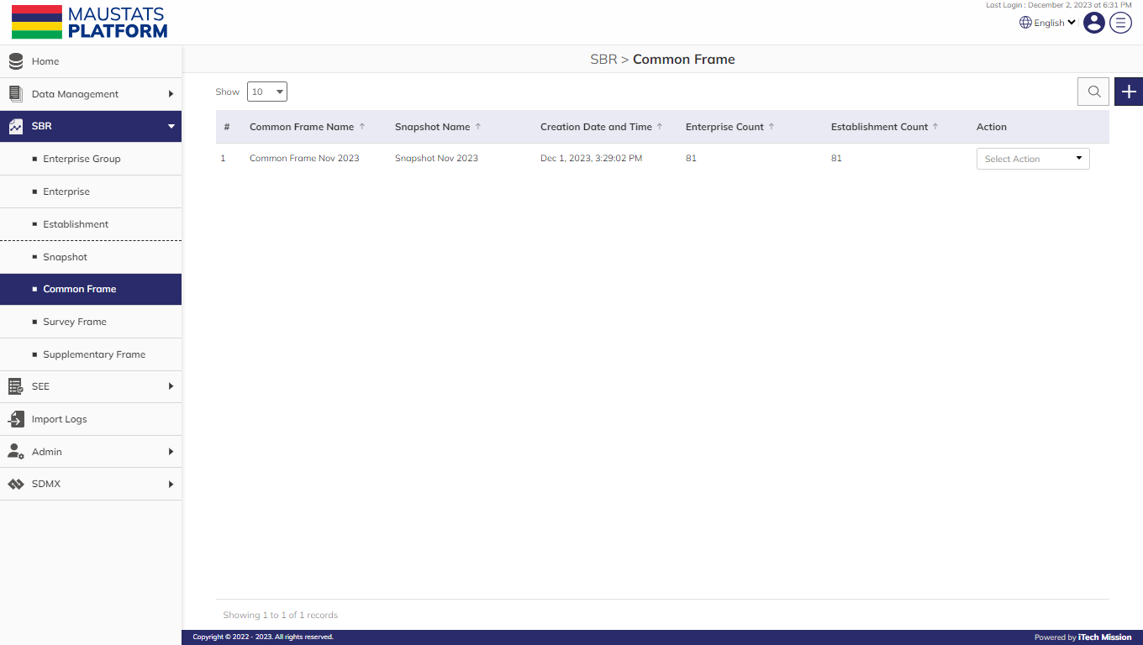**Step 1:** Click on the **Common Frame** option available under SBR to access this sub-module. You have the options to add and delete the elements (see below figure).

### 2.5.1 ADD

**Step 2:** Click on the Plus button available to the right side of the page to add a new common frame (see figure below). Enter the following details to add a new element.

* Select **Snapshot** **Name**
* Update **Common Frame Name**
* Select **Enterprise(s)**

Suppose you want to select the enterprises which are in “<LIVE>” “State”

**Step 3:** Click on the **Filter** button available to the right side of the add common frame popup window to filter the enterprise list based on the specified criteria.

* Enter **Filter Name**
* Select **Column** as **“State”**
* Select **Operator** as **“IN”**
* Select **Value** as **“LIVE”**

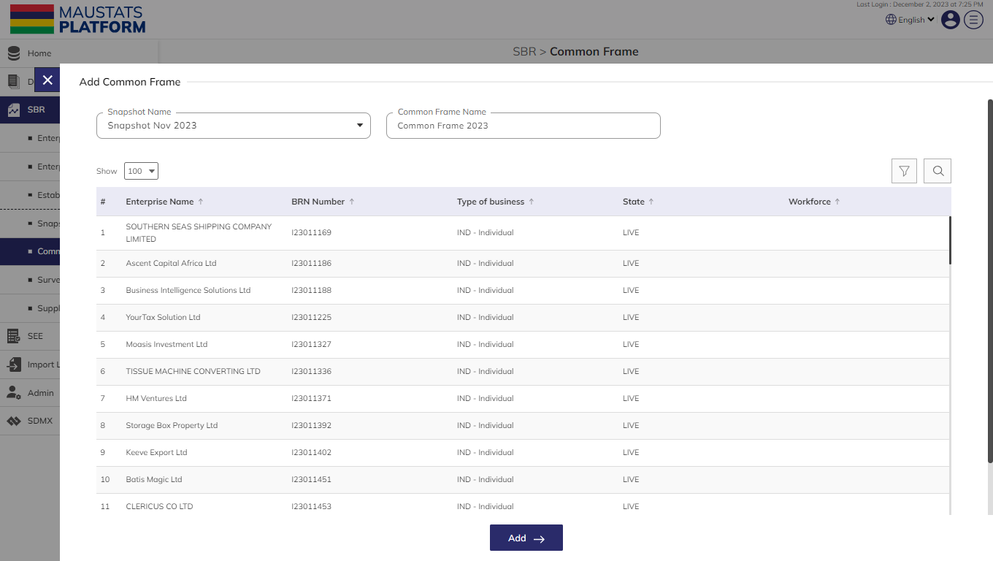**Step 4:** Click on the **Add** button to confirm saving the filter. Click on the **Apply** button to filter the enterprise list based on saved filters (see below figure).

**Step 5:** Click on the **Add** button to save and confirm. You can now view the new common frame added in the list.

**Step 6:** Click to select **View** **Enterprise** option available in the action dropdown to view the list of the enterprise available in the selected common frame.

**Step 7:** Click to select **View** **Establishment** option available in the action dropdown to view the list of the establishments available in the selected common frame.

**Step 8:** Click to select the **Delete** option available in the action dropdown to delete the selected element. A confirmation popup will appear, click yes to confirm deletion of selected elements in case the snapshot is not associated with any survey frame. However, if the snapshot is associated with a survey frame, then the survey frame needs to be deleted before deleting the common frame.

## SURVEY FRAME

This submodule allows the authorized users to create and manage survey frames.

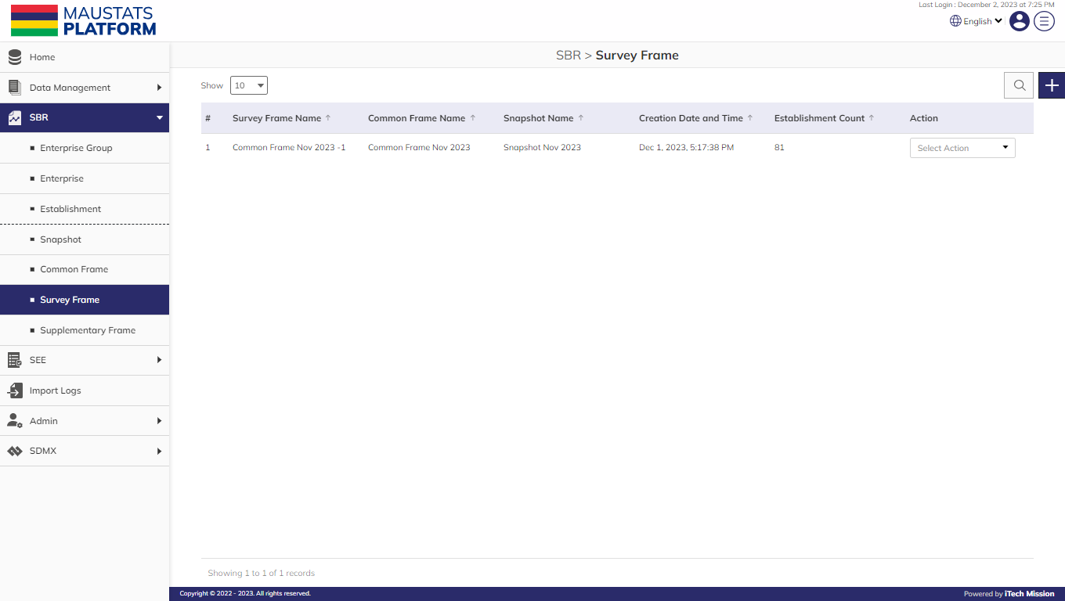**Step 1:** Click on the **Survey Frame** option available under SBR to access this sub-module. You have the options to add and delete the elements (see below figure).

### 2.6.1 ADD

**Step 2:** Click on the Plus button available to the right side of the page to add a new survey frame (see figure below). Enter the following details to add a new element.

* Select **Common Frame**
* Update **Survey Frame Name**
* Select **Establishment(s)**

Suppose you want to select the establishments which are in “<LIVE>” “State”

**Step 3:** Click on the **Filter** button available to the right side of the add common frame popup window to filter the enterprise list based on the specified criteria.

* Enter **Filter Name**
* Select **Column** as **“State”**
* Select **Operator** as **“IN”**
* Select **Value** as **“LIVE”**

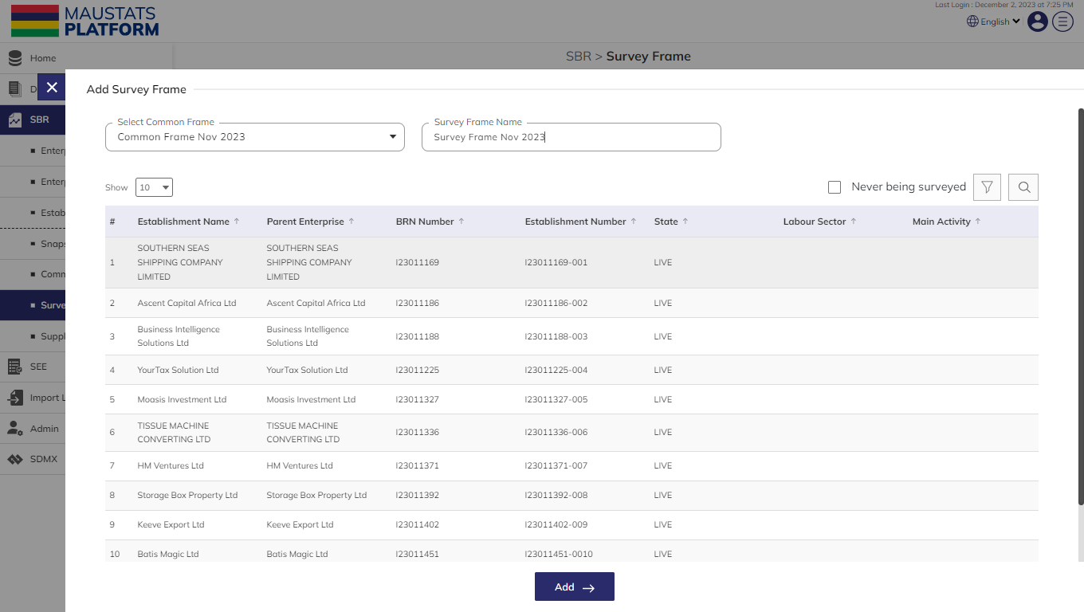**Step 4:** Click on the **Add** button to confirm saving the filter. Click on the **Apply** button to filter the establishment list based on saved filters (see below figure)

**Step 5:** Click on the **Add** button to save and confirm. You can now view the new survey frame added in the list.

**Step 6:** Click to select **View** **Establishment** option available in the action dropdown to view the list of the establishments available in the selected common frame.

**Step 7:** Click to select the **Delete** option available in the action dropdown to delete the selected element. A confirmation popup will appear, click yes to confirm deletion of selected elements in case the survey frame is not associated with any survey cycle. However, if the survey frame is associated with any survey cycle, then all the associated survey cycles need to be deleted before deleting the survey frame.

## SUPPLEMENTARY FRAME

This submodule allows the authorized users to create and manage supplementary frames.

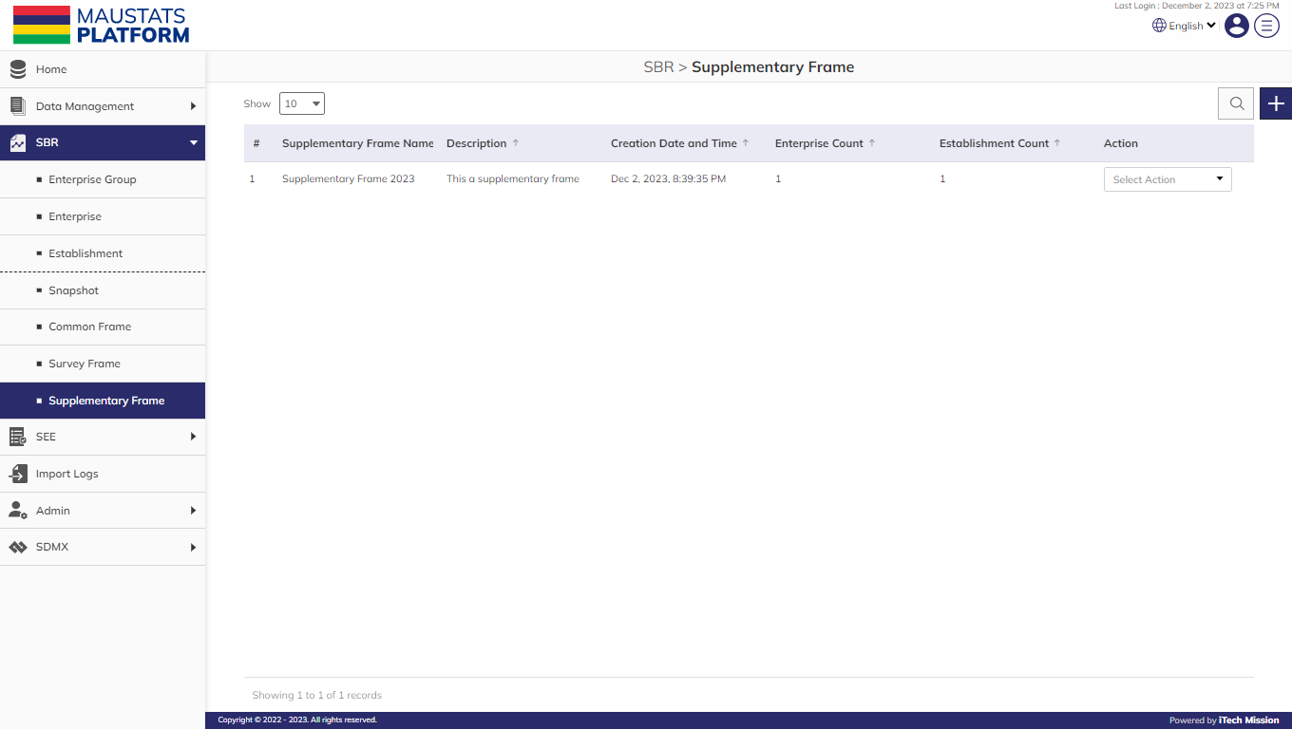**Step 1:** Click on the **Supplementary Frame** option available under SBR to access this sub-module. You have the options to add and delete the elements (see below figure).

### 2.7.1 ADD

**Step 2:** Click on the **Plus** button available to the right side of the page to add a new supplementary frame (see figure below). Enter the following details to add a new element.

* Select **Snapshot** **Name**
* Enter **Supplementary Frame Name**
* Enter **Supplementary Description**

**Step 3:** Click on the **Add** button to save and confirm. You can now view the new supplementary frame added in the list.

**Step 4:** Click to select **View** **Enterprise** option available in the action dropdown to view the list of the enterprises available in the supplementary frame.

**Step 5:** Click to select **View** **Establishment** option available in the action dropdown to view the list of the establishments available in the supplementary frame.

**Step 6:** Click to select the **Delete** option available in the action dropdown to delete the selected element. A confirmation popup will appear; in case the supplementary frame is not associated with any survey cycle. Click yes to confirm deletion of selected elements. However, if the supplementary frame is associated with any survey cycle, then all the associated survey cycles should be deleted before deleting the supplementary frame.



PRODUCT DOCUMENT